 | COMSATS University Islamabad  Department of Computer Science  Assignment 2 [Marks 10]

Class: BSAI-6&7/BDS-7 Submission Deadline: 05-10-2026
Subject: ANN&DL Instructor: Dr. Zobia Rehman

CLO 2: Apply artificial neural network and deep learning models to solve computational problems..

- Apply a suitable perceptron network (single layer/ multi-layer) to solve the logical AND gate. Draw its architecture and show all stages of its training in a table.
- Decide a perceptron network (single layer/ multi-layer) to solve the XOR gate problem. Draw its architecture and show all stages of its training in a table.

- Apply a suitable perceptron network (single layer/ multi-layer) to solve the following problem. Draw the architecture of your chosen neural network. Show all stages of its training in a table.

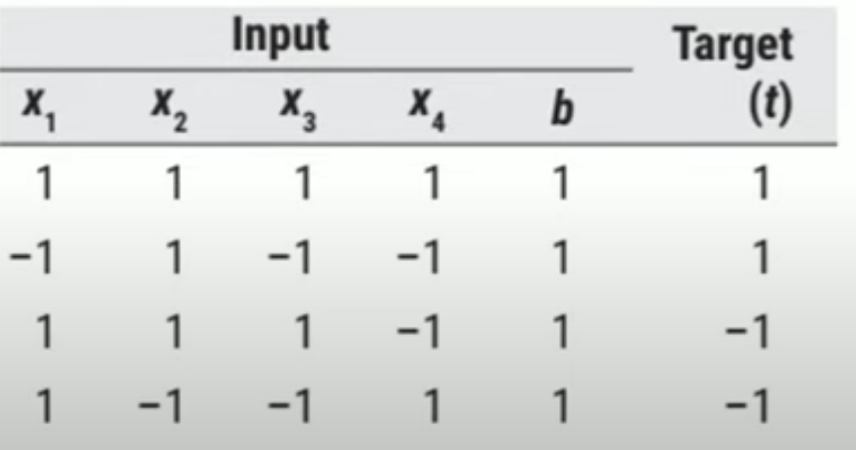

- Apply a suitable neural network (adaline/ madaline) to solve the problem given in question-3. Draw the architecture of your chosen neural network. Show all stages of its training in a table.
- A model produces predictions for one data point across five training runs:
0.65, 0.70, 0.75, 0.68, 0.72. Actual target y = 0.90.
Assume expected prediction is the arithmetic mean.
Tasks:
a. Calculate the mean prediction.
b. Calculate bias = E[ŷ] − y.
c. Calculate squared bias.
d. Calculate variance = (1/n) Σ(ŷᵢ − mean(ŷ))².
e. Calculate the mean squared error (MSE) of the predictions.
f. Explain how high bias and high variance affect model performance.

- A fully connected layer has nᵢₙ = 4 and nₒᵤₜ = 2.
Use Xavier uniform initialization:
W ~ U(−√[6/(nᵢₙ + nₒᵤₜ)], +√[6/(nᵢₙ + nₒᵤₜ)]).
Tasks:
a. Calculate the lower and upper bounds.
b. Calculate the range of possible initial weights.
c. If a weight is sampled as 0.45, determine whether it lies within the valid range.
d. Calculate variance using Var(W) = (b − a)² / 12, where a and b are the bounds.
e. Explain why Xavier initialization is commonly used with sigmoid and tanh activations.

- A neural network layer has nᵢₙ = 6. Weights use He normal initialization:
W ~ N(0, 2/nᵢₙ).
Tasks:
a. Calculate the variance of the initial weights.
b. Calculate the standard deviation.
c. If a weight is sampled as 0.5, explain whether it is possible under this initialization.
d. Explain why He initialization is commonly used with ReLU.

